# E:\Users\simon.roche\AppData\Local\Microsoft\Windows\Temporary Internet Files\Content.Word\Evidencing the Impact of the Primary PE and Sport Premium Template 2019 7.3 Images_Page_1.jpg

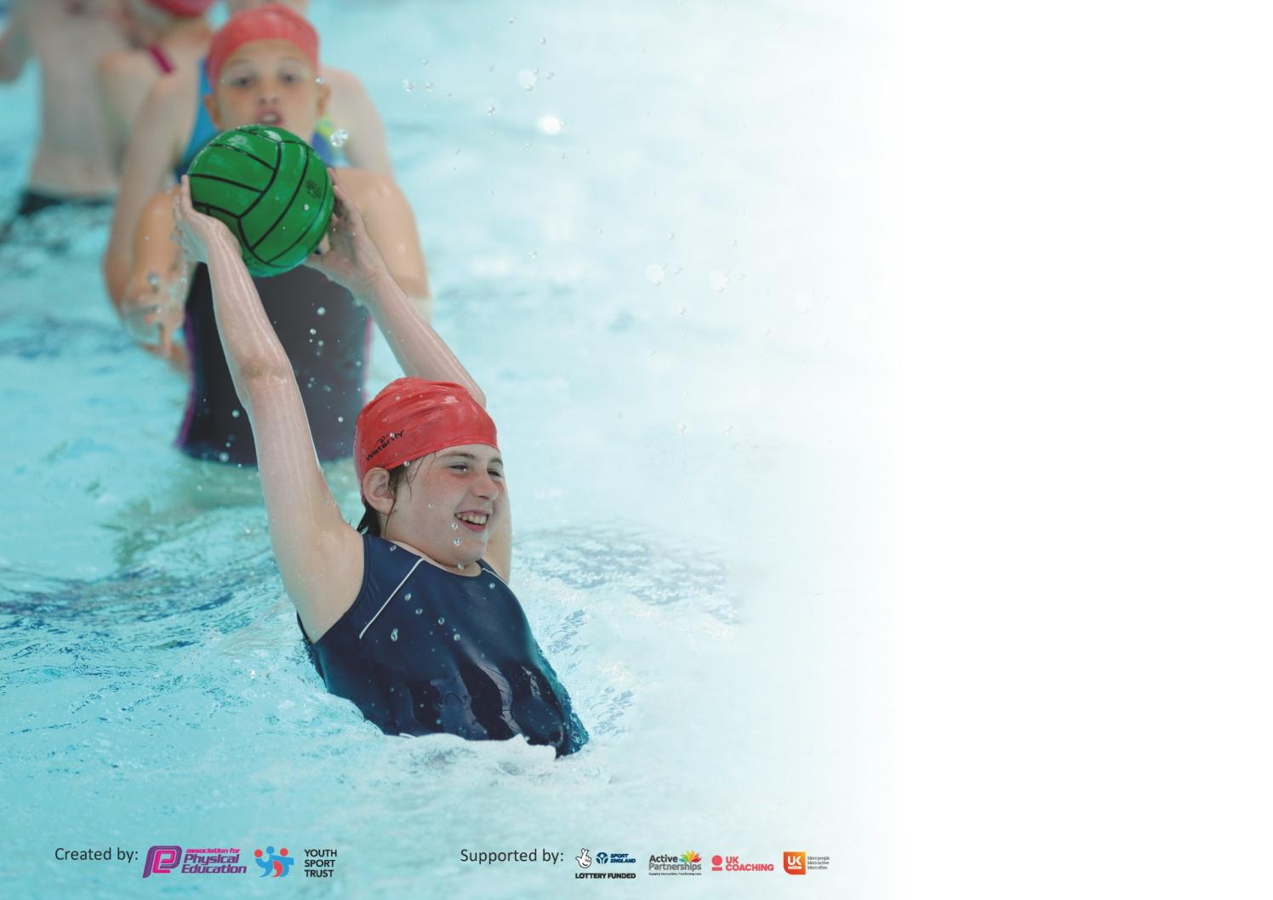

It is important that your grant is used effectively and based on school need. The [Education Inspection Framework](https://assets.publishing.service.gov.uk/government/uploads/system/uploads/attachment_data/file/843108/School_inspection_handbook_-_section_5.pdf) (Ofsted 2019 p64) makes clear there will be a focus on **‘whether leaders and those responsible for governors all understand their respective roles and perform these in a way that enhances the effectiveness of the school’**.

Under the [Quality of Education criteria](https://assets.publishing.service.gov.uk/government/uploads/system/uploads/attachment_data/file/843108/School_inspection_handbook_-_section_5.pdf) (p41) inspectors consider the extent to which schools can articulate their curriculum (INTENT), construct their curriculum (IMPLEMENTATION) and demonstrate the outcomes which result (IMPACT).

To assist schools with common transferable language this template has been developed to utilise the same three headings which should make your plans easily transferable between working documents.

Schools must use the funding to make **additional and sustainable** improvements to the quality of Physical Education, School Sport and Physical Activity (PESSPA) they offer. This means that you should

use the Primary PE and Sport Premium to:

* Develop or add to the PESSPA activities that your school already offer
* Build capacity and capability within the school to ensure that improvements made now will benefit pupils joining the school in future years

Please visit [gov.uk](https://www.gov.uk/guidance/pe-and-sport-premium-for-primary-schools) for the revised DfE guidance including the 5 key indicators across which schools should demonstrate an improvement. This document will help you to review your provision and to report your spend. DfE encourages schools to use this template as an effective way of meeting the reporting requirements of the Primary PE and Sport Premium.

We recommend you start by reflecting on the impact of current provision and reviewing the previous spend.

Schools are required to [publish details](https://www.gov.uk/guidance/what-maintained-schools-must-publish-online#pe-and-sport-premium-for-primary-schools) of how they spend this funding as well as on the impact it has on pupils’ PE and sport participation and attainment by the end of the summer term or by **31st July 2020** at the latest.

We recommend regularly updating the table and publishing it on your website throughout the year. This evidences your ongoing self-evaluation of how you are using the funding to secure maximum, sustainable impact. Final copy must be posted on your website by the end of the academic year and no later than the 31st July 2020. To see an example of how to complete the table please click [HERE](http://www.afpe.org.uk/physical-education/wp-content/uploads/afPE-Example-Template-Indicator-2018-Final.pdf).

Support for review and reflection - considering the 5 key indicators from DfE, what development needs are a priority for your setting and your pupils now and why? Use the space below to reflect on previous spend and key achievements and areas for development.

|  |  |
| --- | --- |
| Key achievements to date until July 2019: | Areas for further improvement and baseline evidence of need: |
| Targeted improvement in SUC involvement of children who are less active/able.  Variety of sports offered to all children.  Competition participation and success, representing the borough across multiple sports.  Support for teachers who are lesson confident  Specialist Competition support | .  Swimming – Covid posed a problem to tackling this goal as our swimming catch up was going to be in the final term.  We have carried over money which can be used for this support. |

|  |  |
| --- | --- |
| Meeting national curriculum requirements for swimming and water safety. |  |
| What percentage of your current Year 6 cohort swim competently, confidently and proficiently over a distance of at least 25 metres?  **N.B.** Even though your pupils may swim in another year please report on their attainment on leaving  primary school at the end of the summer term 2020. | 65% |
| What percentage of your current Year 6 cohort use a range of strokes effectively [for example, front crawl, backstroke and breaststroke]? | 56% |
| What percentage of your current Year 6 cohort perform safe self-rescue in different water-based situations? | 22% |
| Schools can choose to use the Primary PE and Sport Premium to provide additional provision for swimming but this must be for activity **over and above** the national curriculum requirements. Have you used it in this way? | Yes/No |

**Action Plan and Budget Tracking**

Capture your intended annual spend against the 5 key indicators. Clarify the success criteria and evidence of impact that you intend to measure to evaluate for pupils today and for the future.

|  |  |  |  |  |
| --- | --- | --- | --- | --- |
| **Academic Year:** 2019/20 | **Total fund allocated:** £18,400 | **Date Updated: 20/06/20** | |  |
| **Key indicator 1:** The engagement of all pupils in regular physical activity – Chief Medical Officer guidelines recommend that primary school pupils undertake at least 30 minutes of physical activity a day in school | | | | Percentage of total allocation: |
| 45% |
| **Intent** | **Implementation** | | **Impact** |  |
| Your school focus should be clear what you want the pupils to know and be able to do and about  what they need to learn and to  consolidate through practice: | Make sure your actions to achieve are linked to your intentions: | Funding allocated: | Evidence of impact: what do pupils now know and what can they now do? What has changed?: | Sustainability and suggested next steps: |
| Ensuring that all children are active targeting the less active children with sessions focused on them.  Offering a range of after school club activities.  Introduction of Daily Mile  Supported children during lockdown with specialist PE | Provide a wide range of equipment for play times.  Encourage walking to school.  Train up staff in playground games.  Provide a variety of after school club options with discounts.  Offer shake up club to children showing a lack of physical exercise.  Introduce Daily Mile (once a week) | CPD/ LPESSN - £3500  Shake Up Club - £1000  Subsidised ASC £1500  Lockdown support £2500 | Staff have been trained in playground games, and have been seen to lead and encourage.  Children playing variety of games at break-times, including table tennis on the roof, which had limited options previously.  Shake up club and After school clubs have seen a strong uptake.  Children complete their mile | Sustainability – Staff have received CPD on playground games  Equipment has been purchased (Table tennis table is of good quality and should have a long life)  ASC could be made to pay for themselves in future as we are monitoring income…  Next Steps – Continue to monitor the % of children taking part in PE outside of lesson time  Continuation and monitoring of SUC to identify trends. |
| **Key indicator 2:** The profile of PESSPA being raised across the school as a tool for whole school improvement | | | | Percentage of total allocation: |
| 60% |
| **Intent** | **Implementation** | | **Impact** |  |
| Your school focus should be clear what you want the pupils to know and be able to do and about  what they need to learn and to  consolidate through practice: | Make sure your actions to achieve are linked to your intentions: | Funding allocated: | Evidence of impact: what do pupils now know and what can they now do? What has changed?: | Sustainability and suggested next steps: |
| PE to be seen as something the school does well and something that all pupils are involved in and enjoy. Increase children’s life-long enjoyment of physical activity by rooting it in positive early memories  Teachers supported in delivery and trained.  Opportunities for Gifted and Talented and less able | Ensure all classes to a wide range of sports and have opportunities for our achievements to be shared.  Teachers to be confident in delivery, learning from experts.  Benefits of physical wellbeing shown to link with all areas of learning. | PESSN £3500  Support teaching and groups - £5000  SUC £1000  G&T support - £1200 | Children have taken part in a wide range of sports and a large proportion have competed within the borough, and gifted and talented pupils have represented Southwark through our links with PESSN. Each achievement is shared with the school in assemblies and the wide range of sports is mentioned and highlighted.  Training has been provided to staff and coaches have been hired to support delivery of gymnastics and dance as well as a highlighted class for support.  Extra coaching was provided to support our gifted and talented children | Continuation through work with PESSN and sharing of achievements.  ‘One on, one off’ expert lessons.  Sustainable through developing relationships with sports providers who offer funded opportunities, such as chance to shine.  Next Steps – Continuation of good practice and sharing of achievements and opportunities across the school. |

|  |  |  |  |  |
| --- | --- | --- | --- | --- |
| **Key indicator 3:** Increased confidence, knowledge and skills of all staff in teaching PE and sport | | | | Percentage of total allocation: |
| 50% |
| **Intent** | **Implementation** | | **Impact** |  |
| Your school focus should be clear | Make sure your actions to | Funding | Evidence of impact: what do | Sustainability and suggested |
| what you want the pupils to know | achieve are linked to your | allocated: | pupils now know and what | next steps: |
| and be able to do and about | intentions: |  | can they now do? What has |  |
| what they need to learn and to |  |  | changed?: |  |
| consolidate through practice: |  |  |  |  |
| To ensure that all staff and confident in their delivery of PE lessons and have experts to support them in their learning allowing children to benefit from these skills. | Continuation of CPD with PESSN  Paired teaching and learning through work with SJ and AW in gymnastics and dance and outdoor PE with AW for 4A.  Support for NQT with PESSN | PESSN – £3500  Support/CPD - £5000 | Teachers have expressed their confidence increasing through work alongside expert coaches in dance/gym.  Children have received the highest possible level of teaching.  Identified teachers have been provided CPD through PESSN.  TAs have received additional training.  NQT has been supported through use of experts at PESSN. | Staff are capable of delivering lessons to a high level.  Continuation of support for new teachers/those who express need for additional help through work with sports coaches.  Continue CPD though PESSN.  Identify gaps and train new staff. |
| **Key indicator 4:** Broader experience of a range of sports and activities offered to all pupils | | | | Percentage of total allocation: |
| 40% |
| **Intent** | **Implementation** | | **Impact** |  |
| Your school focus should be clear | Make sure your actions to | Funding | Evidence of impact: what do | Sustainability and suggested |
| what you want the pupils to know | achieve are linked to your | allocated: | pupils now know and what | next steps: |
| and be able to do and about | intentions: |  | can they now do? What has |  |
| what they need to learn and to |  |  | changed?: |  |
| consolidate through practice: |  |  |  |  |
| To ensure that all children get to participate in sport outside of their PE lessons and that a broad range is offered so that children are engaged and inspired. | Offer a wide range of sports including new or alternative sports. | LPESSN£3500  SEN/SUC £1500  ASC - £1500 | Children have had opportunities to participate or be coached in a range of new or alternative sports including: BMX, NFL, Taekwondo, Boxing, Volleyball, Badminton, Golf, Parkour and Circus Skills  Children have enjoyed taking part in these sports and shown interest in continuing these outside of school. | Sustainability – Look for funded opportunities and build links, such as through the BMX track. Use PESSN to build NFL relationship and compete in wide variety.  Next Steps: Offer a wider range and different sports again next year including new ones and ones highlighted through pupil voice. |

|  |  |  |  |  |
| --- | --- | --- | --- | --- |
| **Key indicator 5:** Increased participation in competitive sport | | | | Percentage of total allocation: |
| 25% |
| **Intent** | **Implementation** | | **Impact** |  |
| Your school focus should be clear | Make sure your actions to | Funding | Evidence of impact: what do | Sustainability and suggested |
| what you want the pupils to know | achieve are linked to your | allocated: | pupils now know and what | next steps: |
| and be able to do and about | intentions: |  | can they now do? What has |  |
| what they need to learn and to |  |  | changed?: |  |
| consolidate through practice: |  |  |  |  |
| Children to compete both within the school, our borough and region to the best of their ability and to celebrate their achievements. | Train for and enter a wide range of competitions – looking for Gifted and Talented opportunities/SEN and those for a whole class. | £3500 – PESSN  Competition entries - £350  Competition support - £650  G&T sessions - £1200 | School were on their way to 100% competition participation before lockdown.  Children have (or were going to) represented Southwark or South London at: Cross Country, hockey and football this year after winning borough wide competitions – these achievements resonate through the school to create a competitive ethos.  Children competed in sports outside of PESSN too as well as virtual competitions. | Continue to enter all competitions available to use.  Keep track of pupils who have not yet taken part and ensure opportunities are there.  Continue to celebrate achievement. |

|  |  |
| --- | --- |
| Signed off by | |
| Head Teacher: |  |
| Date: |  |
| Subject Leader: | Paul Higgins |
| Date: | 16/07/2020 |
| Governor: |  |
| Date: |  |